Supplementary data for CCC2021 paper

Table 1. Design parameters of co-generation AA-CAES

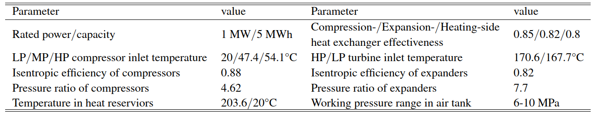

Table 2. System parameters of energy hub

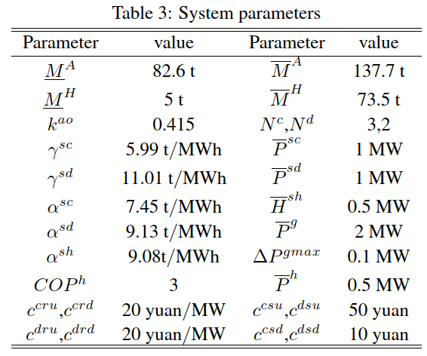

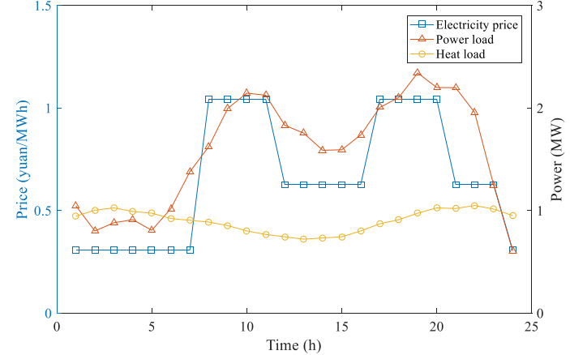

Figure 1. Electricity price and load demands